**Problem Statement**

**Product Dissection for top leading Platforms**

Welcome to this case study on dissecting and designing products for top leading platforms. In this case study, you will delve into the intriguing world of schema design for a prominent platform of your choice. Your task is to choose a top leading platform, research its features, and meticulously craft a schema design that encapsulates the essence of its functionality. By focusing on key entities, attributes, and relationships, you will gain invaluable insights into how data architecture drives the platform's effectiveness.

**Step 1: Choose a Leading Platform**

Select a leading platform of your choice, which could span various domains such as social media, e-commerce, finance, or any other industry. This choice will form the foundation of your exploration into its schema design.

**Step 2: Research:**

Thoroughly research the platform you have selected. Investigate its core features, functionalities, and user interactions. Identify the top features that define its user experience and contribute significantly to its popularity.

**Step 3: Product Dissection and Real World Problems solved by the platform**

In this step, you will meticulously analyse the platform's standout features and how they provide innovative solutions to real-world challenges. By identifying key functionalities that resonate with users, you'll unravel how the platform effectively addresses problems and enhances user experiences. This dissection will serve as the foundation for understanding how the schema design aligns with the platform's core objectives.

**Step 4: Case Study on the real world problems and approach to solving them**

In this pivotal step, you will expand on the real-world challenges uncovered in Step 3 through a comprehensive case study. Delve into specific instances where users encountered difficulties and showcase how the platform's unique features provided effective solutions. By dissecting the approach taken by the platform to overcome these challenges, you'll gain a deeper appreciation for the platform's user-centric design philosophy and how it shapes the schema design.

**Step 5: Schema Design Based on Top Features**

Based on the features you have identified, craft a schema design that reflects the platform's data structure. Focus on the key entities, attributes, and relationships that underpin the chosen features. Your schema should capture the essence of how the platform organises and utilises its data.

**Step 6: Rationale Behind the Design**

While creating the schema design, consider the rationale behind the platform's choices. Reflect on why certain entities and relationships were chosen and how they align with the platform's goals. This will help you understand the strategic decisions driving the schema's architecture.

**Step 7: Create an ER Diagram**

Utilise tools like the Miro platform or similar applications to create an illustrative Entity-Relationship (ER) diagram. This diagram should vividly depict the entities, attributes, and relationships present within your schema design. The ER diagram will serve as a visual representation of your insights.

**Step 8: Presentation of Findings**

Present your findings in a clear and concise manner. Showcase your understanding of how the schema design impacts the platform's functionality and user experience. Explain how your chosen features are integrated into the schema and how the schema's structure supports the platform's objectives.

**Task Details:**

1. **Answer Submission:** Your submission should include well-structured solutions for all provided questions related to product schema designs.
2. **Video Creation:** Create an informative and engaging video where you thoroughly explain the Case Study.
3. **Depth and Clarity:** Ensure your solutions are detailed and showcase your understanding of product schema design principles. Similarly, in the video, provide clear explanations that are easy to understand for a wide audience.
4. **Creativity Encouraged:** You are welcome to utilise visuals, diagrams, or creative elements to enhance the clarity and impact of your explanations.

**Note:**

1. Duplicate this document and proceed to write your solutions and prepare your video.
2. Include the video link in this document before final submission.

Best of luck in completing this project and showcasing your prowess in dissecting and designing product schema for leading platforms! **For reference, we have also conducted a case study on Instagram, which you can find below. This case study will provide you with valuable insights into how schema design plays a pivotal role in shaping the functionality and success of a prominent platform.**

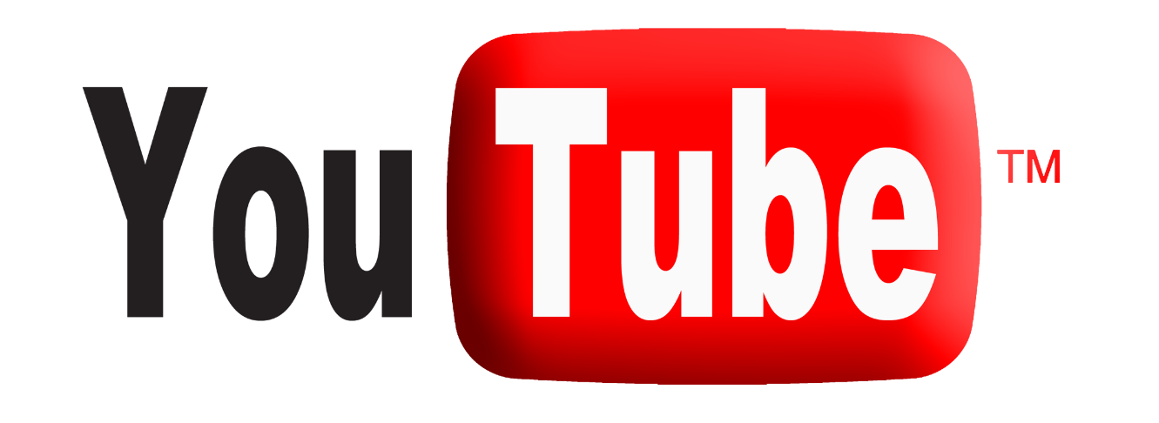

**Product Dissection for YouTube**

### **Company Overview:**

YouTube, established in 2005 and acquired by Google in 2006, is a worldwide video-sharing stage that permits users to upload, share, and view a wide range of video content. YouTube is a subsidiary of Alphabet Inc. With a huge number of stakeholders, YouTube has turned into a famous internet phenomenon, impacting web culture and assisting content makers as a stage for sharing their content around the globe. It offers in-built attributes like algorithmic suggestions, monetization through the YouTube Partner Program, and live streaming, which affects online education and entertainment. YouTube proceeds to improve and adjust to the developing landscape of online content.

### **Product Dissection and Real-World Problems Solved by YouTube:**

YouTube is a widely popular video-sharing platform that has become a cultural phenomenon and a cornerstone of online content consumption. It has addressed real-world problems through evolving product offerings.

1. **Video Sharing:** YouTube allows users to upload, share, and view videos. It supports a wide range of content, including vlogs, tutorials, music videos, documentaries, and more.
2. **Global Reach:** As a global platform, YouTube has a vast audience, transcending geographical and cultural boundaries. It provides content creators with the opportunity to reach a diverse and international viewership.
3. **User-Generated Content:** One of YouTube's defining features is its emphasis on user-generated content. Anyone with a Google account can create a YouTube channel and share their videos with the world.
4. **Monetization Opportunities:** YouTube offers a monetization program called the YouTube Partner Program (YPP), allowing eligible content creators to earn money through advertising, channel memberships, and other features.
5. **Variety of Content Categories:** The platform caters to a wide range of interests and niches, from entertainment and education to technology, gaming, and more. This diversity of content contributes to its broad appeal.
6. **Social Features:** YouTube incorporates social elements, such as commenting, liking, and sharing. Users can subscribe to channels to stay updated on new content from their favorite creators.
7. **Algorithmic Recommendations:** YouTube's recommendation system uses machine learning algorithms to suggest videos based on a user's watch history, preferences, and trending content. This feature has contributed to the platform's ability to keep users engaged.
8. **Live Streaming:** In addition to pre-recorded videos, YouTube supports live streaming, allowing creators to interact with their audience in real-time. Live events, interviews, and gaming streams are popular on the platform.
9. **Educational and Informative Content:** YouTube has become a valuable resource for educational and informative content, with many creators producing tutorials, how-to guides, and informative videos on a wide range of topics.

Overall, YouTube has evolved from a simple video-sharing site into a multifaceted platform that influences entertainment, education, and communication on a global scale. Its impact on digital culture and the media landscape continues to grow as it remains a primary source of online video content for billions of users worldwide. YouTube has played a significant role in customizing internet culture and fostering new trends, memes, and communities. It has also been a launching pad for the careers of many content creators, musicians, and influencers

### **Case Study: Real-World Problems and YouTube's Innovative Solutions**

YouTube, a leading video-sharing platform, has overcome significant challenges to ensure a safer and more reliable user experience. Addressing issues like inappropriate content, copyright violations, brand safety concerns for advertisers, and combating misinformation, YouTube has implemented innovative solutions, showcasing its commitment to maintaining a secure and trustworthy online environment. Let's explore these challenges and the corresponding solutions that have shaped YouTube's evolution.

**1. Challenge: Inappropriate Content Moderation**

**Description:**

YouTube faced the challenge of effectively moderating and removing inappropriate content, including violence, hate speech, and explicit material. The sheer volume of content uploaded by users made manual moderation impractical.

**Solution: Advanced Content Detection Algorithms**

YouTube implemented sophisticated machine learning algorithms that automatically analyze and categorize content. These algorithms can detect policy violations and inappropriate material, allowing for swift removal and ensuring a safer and more compliant platform.

**2. Challenge: User-Generated Copyright Violations**

**Description:**

With the vast amount of user-generated content, YouTube encountered issues related to copyright violations. Users were uploading videos that included copyrighted material without proper authorization, leading to concerns from copyright owners.

**Solution: Content ID System**

YouTube introduced the Content ID system, a digital fingerprinting technology that allows copyright owners to identify and manage their content. This automated system helps prevent unauthorized use by matching uploaded content against a database of copyrighted material, enabling copyright holders to take appropriate actions.

**3. Challenge: Advertiser Brand Safety**

**Description:**

Advertisers were concerned about their brand safety on YouTube, fearing that their ads might appear alongside controversial or unsuitable content. This posed a risk to brand reputation and raised questions about ad placement.

**Solution: Brand Safety Controls**

YouTube implemented brand safety controls, giving advertisers the ability to define where their ads appear. Advertisers can set preferences and parameters, ensuring their ads are displayed in contexts aligned with their brand values. This feature enhances advertiser confidence and protects brand reputation.

**4. Challenge: Tackling Misinformation**

**Description:**

YouTube grappled with the spread of misinformation on its platform. Users were encountering misleading content, and the platform needed effective measures to address and counteract false information.

**Solution: Information Panels and Fact-Checking**

YouTube implemented information panels alongside videos to provide additional context and details, helping users make more informed decisions. Additionally, the platform collaborates with fact-checking organizations to verify content accuracy and flag misleading information, promoting a more responsible and reliable content ecosystem.

**Conclusion:**

In navigating challenges related to content moderation, copyright violations, brand safety, and misinformation, YouTube has demonstrated its commitment to user safety and platform integrity. Through the implementation of advanced technologies, user-centric features, and collaborative efforts, YouTube continues to evolve and set industry standards for content platforms. These innovative solutions not only address existing issues but also position YouTube as a leader in creating a more secure and trustworthy digital space for its global community of users, creators, and advertisers.

### **Top Features of YouTube:**

YouTube is a feature-rich platform that offers a diverse range of tools and functionalities for both content creators and viewers. Here are some of the top features of YouTube:

**1. Video Upload and Sharing:**

Users can easily upload and share videos on the platform, making it accessible to a global audience.

**2. Content Discovery:**

The recommendation algorithm suggests personalized content to users based on their watch history and preferences, facilitating content discovery.

**3. Subscriptions:**

Users can subscribe to channels to receive updates on new videos from their favorite creators.

**4. Live Streaming:**

Content creators can engage with their audience in real time through live streaming, fostering interactive experiences.

**5. Monetization:**

The YouTube Partner Program (YPP) allows eligible content creators to monetize their channels through ads, channel memberships, and other revenue streams.

**6. Comments and Interactivity:**

Users can leave comments on videos, fostering a sense of community and interaction between creators and viewers.

**7. Likes and Dislikes:**

Viewers can express their appreciation or dissatisfaction by liking or disliking videos.

**8. Playlists:**

Users can create and share playlists to organize and curate their favorite videos.

**9. YouTube Premium:**

A subscription service that offers an ad-free experience, access to YouTube Originals, offline viewing, and background playback on mobile devices.

**10. YouTube Music:**

A music streaming service integrated with YouTube that provides access to a vast library of songs and music videos.

**11. Analytics and Insights:**

Content creators can access detailed analytics to understand their audience, track performance metrics, and optimize their content strategy.

**12. Community Posts:**

Content creators can share text-based updates, images, and polls with their subscribers through the Community tab.

**13. VR and 360-degree Videos:**

Support for virtual reality (VR) videos and 360-degree videos, providing immersive viewing experiences.

**14. YouTube Shorts:**

A short-form video feature allows creators to make brief, catchy videos similar to other short-form video platforms.

**15. Accessibility Features:**

Closed captions, subtitles, and other accessibility features make videos accessible to a diverse audience.

**16. Parental Controls:**

Parents can use YouTube Kids for a child-friendly experience and set up parental controls on the main platform.

**Conclusion:**

These features contribute to YouTube's status as one of the most popular and influential video-sharing platforms, catering to a wide range of interests and preferences. Keep in mind that new features and updates may be introduced over time, so it's advisable to check YouTube's official announcements for the latest information.

### **Schema Description:**

Designing the complete schema for a platform as large and complex as YouTube involves multiple entities, relationships, and considerations. Here, I'll provide a simplified representation of the essential components of a YouTube-like platform, including entities such as users, videos, channels, comments, and likes. Note that this is a high-level schema, and a real-world implementation would involve more details and optimizations.

**YouTube Schema:**

**1. User Entity:** Represents individual users on the platform with unique identifiers, usernames, email addresses, passwords, and registration dates.

* **UserID (Primary Key):** A unique identifier for each user.
* **Username**: The chosen username for the user's account.
* **Email**: The user's email address for account-related communication.
* **Password**: The secure password associated with the user's account.
* **Registration**_**Date**: The date when the user joined YouTube.

**2. Video Entity:** Captures details about each video, including a unique identifier, uploader information, title, description, upload date, duration, and view count.

* **VideoID** **(Primary Key):** A unique identifier for each video.
* **UserID (Foreign Key referencing User)**: The user who uploaded the video.
* **Title**: The title of the video.
* **Description**: A detailed description of the video content.
* **Upload**_**Date**: The date when the video was uploaded.
* **Duration**: The length of the video.
* **Views**: The number of views the video has received.

**3. Channel Entity:** Contains information about channels, such as a unique identifier, owner details, channel name, description, and creation date.

* **ChannelID (Primary Key):** A unique identifier for each channel.
* **UserID (Foreign Key referencing User):** The user who owns the channel.
* **Channel_Name:** The name of the channel.
* **Description:** A description providing information about the channel.
* **Creation_Date:** The date when the channel was created.

**4. Comment Entity:** Records comments made by users on videos, including a unique identifier, video reference, user reference, comment text, and date.

* **CommentID (Primary Key):** A unique identifier for each comment.
* **VideoID (Foreign Key referencing Video):** The video is commented on.
* **UserID (Foreign Key referencing User):** The user who posted the comment.
* **Text:** The text content of the comment.
* **Comment_Date:** The date when the comment was posted.

**5. Like Entity:** Tracks user likes on videos with a unique identifier, video reference, user preference, and the date of the like.

* **LikeID (Primary Key):** A unique identifier for each like.
* **VideoID (Foreign Key referencing Video):** The video being liked.
* **UserID (Foreign Key referencing User):** The user who liked the video.
* **Like_Date:** The date when the like was registered.

**6. Subscription Entity:** Manages user subscriptions to channels, including a unique identifier, subscriber, and channel references, and the subscription initiation date.

* **SubscriptionID (Primary Key):** A unique identifier for each subscription relationship.
* **SubscriberUserID (Foreign Key referencing User):** The user who is subscribing.
* **ChannelUserID (Foreign Key referencing User):** The user whose channel is being subscribed to.
* **Subscription_Date:** The date when the subscription relationship was initiated.

**7. Tag Entity:** Stores unique identifiers and text content for tags used to categorize videos.

* **TagID (Primary Key):** A unique identifier for each tag.
* **Tag_Text:** The actual text content of the tag.

**8. VideoTag Entity:** Links videos with tags through unique identifiers, video, and tag references.

* **VideoTagID (Primary Key):** A unique identifier for each association between a video and a tag.
* **VideoID (Foreign Key referencing Video):** The video associated with the tag.
* **TagID (Foreign Key referencing Tag):** The tag associated with the video.

**9. Category Entity:** Contains information about video categories, including a unique identifier and category name.

* **CategoryID (Primary Key):** A unique identifier for each video category.
* **Category_Name:** The name of the video category.

**Relationships:**

**Users create Videos (One-to-Many: User to Video):**

* One user creates many videos.
* Each video is associated with one user.

**Videos belong to Channels (One-to-Many: Channel to Video):**

* One channel has many videos.
* Each video belongs to one channel.

**Users comment on Videos (One-to-Many: User to Comment):**

* One user posts many comments.
* Each comment is related to one user and one video.

**Users like Videos (Many-to-Many: User to Video through Like):**

* One user can like many videos.
* One video can be liked by many users.

**Users subscribe to Channels (One-to-Many: Channel to Subscription):**

* One user can subscribe to many channels.
* Each subscription is related to one user and one channel.

**Videos have Tags (Many-to-Many: Video to Tag through VideoTag):**

* One video can have many tags.
* One tag can be associated with many videos.

**Videos belong to Categories (Many-to-One: Video to Category):**

* One video belongs to one category.
* One category can have many videos.

**ER Diagram:**

This Entity-Relationship (ER) diagram outlines the core structure of YouTube. It visually represents key entities, such as users, videos, channels, comments, likes, subscriptions, tags, and categories, along with their relationships, providing a succinct overview of the platform's foundational data model. Through this diagram, we can understand the platform’s dynamics.

* PK: Primary Key.
* FK: Foreign Key.

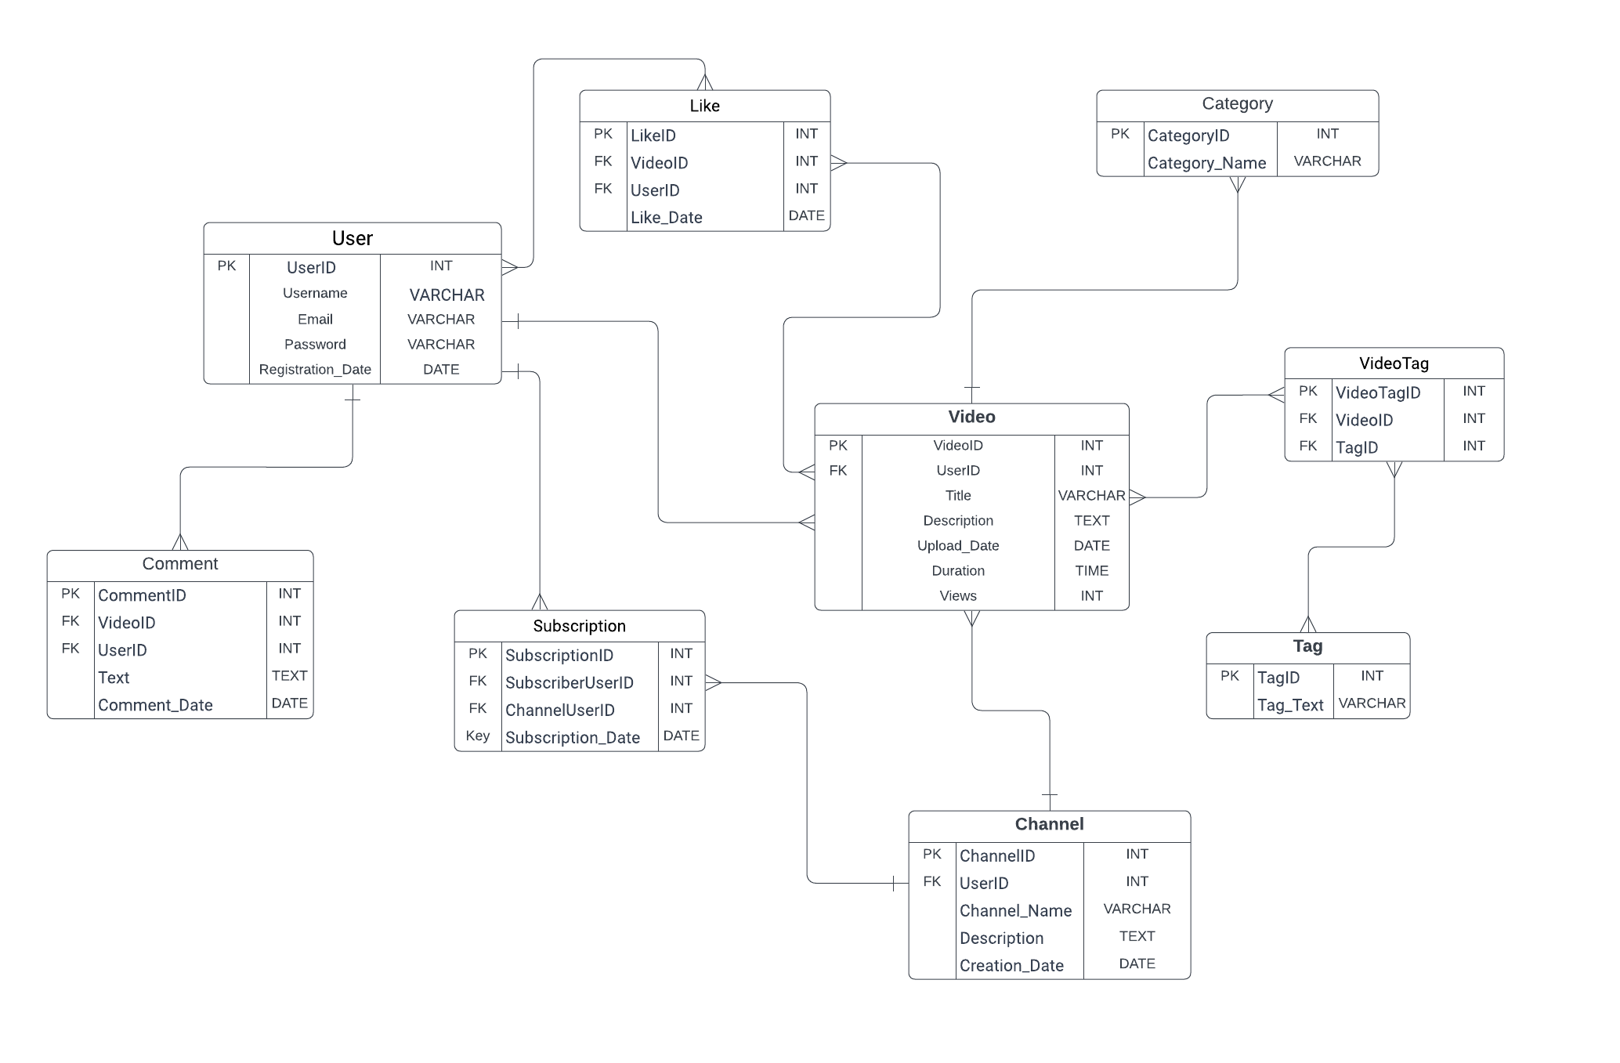

### **Conclusion**

In this case study, we explored the schema design and Entity-Relationship diagram of YouTube. YouTube has transformed the landscape of visual content sharing, reshaping how people connect and express creativity. The platform's sophisticated data model, encompassing entities such as user, video, comment, like, subscription, tag, channel, video tag, and category, establishes the groundwork for its smooth operation. Comprehending this schema provides valuable insights into how YouTube adeptly navigates the intricacies of user interactions and content distribution, playing a pivotal role in its enduring popularity and sustained growth within the realm of online video-sharing platforms.